
Check List - Goods Lift 4 Colum
Sr. No | Description | Remark
1 | Load Capacity - Kgs | 500Kg
2 | Load type (with pallet / without pallet) | Without pallet
3 | Lift height ( No of Floor) | 3000 mm
4 | Platform Size - ( Length X Width X Height)  Please Specify | 1000(w) X1200(l)
5 | Available Space -( Length X Width) | Having wall support
6 | Type of platform (Chequered plate / plain sheet) | Plain sheet
7 | Gate on platform (Collapsible / Hinged / Mesh) please specify | Collapsible
8 | Gate on floor (Collapsible / Hinged / Mesh) please specify | collapsible
9 | Wire Mesh covered (1800mm height / Full covered) | full
10 | Entry & exit side (please specify in detail) see below option | F
11 | Standard Color (platform Yellow / frame Black) Please specify if special color required | Platform yellow/ frame black
12 | Other requirement please specify in details
13 | Application Details
Note:- For more details please share the installation location picture with requirement.
Collapsible Gate on Floor / On Platform |  | Mesh Gate on Platform / Floor
 |  | 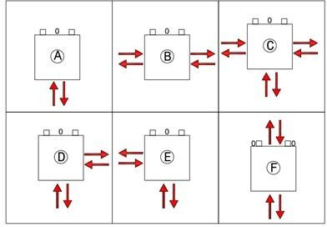
1800mm Height Mesh Protection / Full Mesh Protection from out side |  | ENTRY / EXIT Option (A/B/C/D/E/F)


